

**User’s Guide for:**

**Murdoch and Monsters**

**M&M**

“Something funny here or not so funny!”™

All work Copyright © 2021 by Team Mysterios

Written by all members of Team Mysterios

Version # 1.0

Friday, October 29, 2021

Table of Contents

**Running the program** 2

**Gameplay** 2

**Levels** 8

**Classes** 8

**Enemies** 8

**Running the program**

Open the Executable folder and select the houses.exe file to run the program.

**Gameplay**

|  |  |
| --- | --- |
| **Key bind** | **Functionality** |
| Arrow keys | Camera movement on campus level (spawn) |
| ~ | End turn |
| Left mouse click | Select UI button |
| A/a | Look down on campus level (spawn) |
| Q/q | Look up on campus level (spawn) |
| X/x | Look right on campus level (spawn) |
| Z/z | Look left on campus level (spawn) |
| shift | sprint |

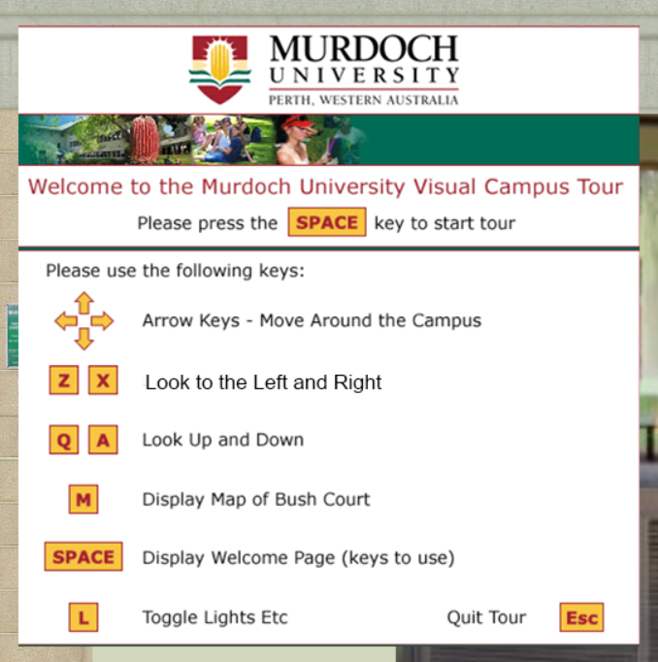On starting the you are presented with figure 1, giving you a general control guide for the spawn area.

Figure 1: Welcome screen for game, controls guide

Upon entering the world you will be placed in front a door that when entered you will be forced to select a character.

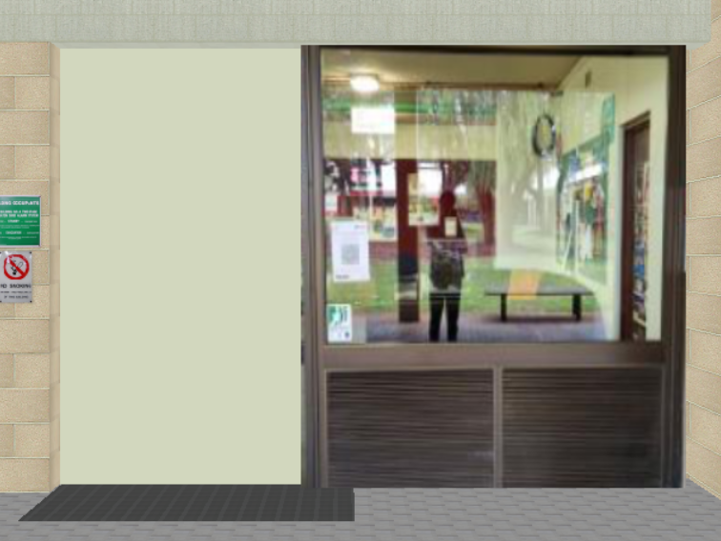

Figure 2: Front door, entrance to player selection menu

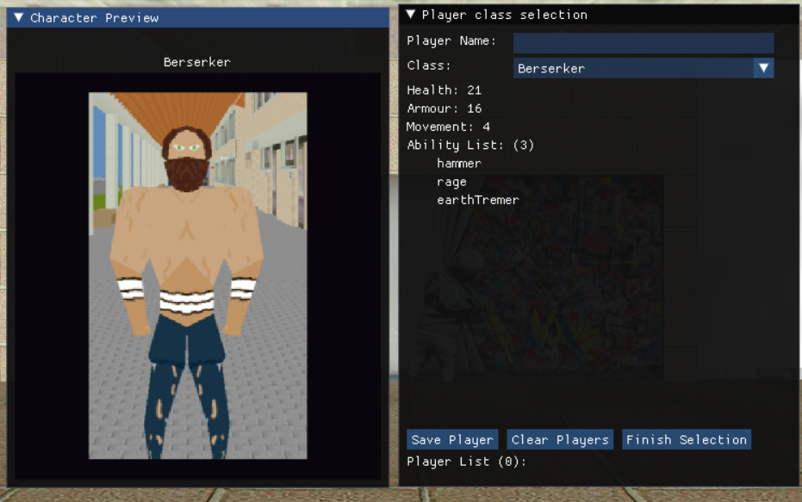This character selection screen shows you a preview of the class model (on the right) and the stats for that class including abilities. To save a character you must have something in the “name” input space and you cannot finish selection without saving at least one character. The player selection menu also allows you to clear all saved players from the list.

Figure 3: Shows the player selection screen (right is preview of class model with name & class, Left is class info and input area)

Once the players have been finalised you can go towards the iron doors at the back of the room and they will open revealing a portal to the game level.

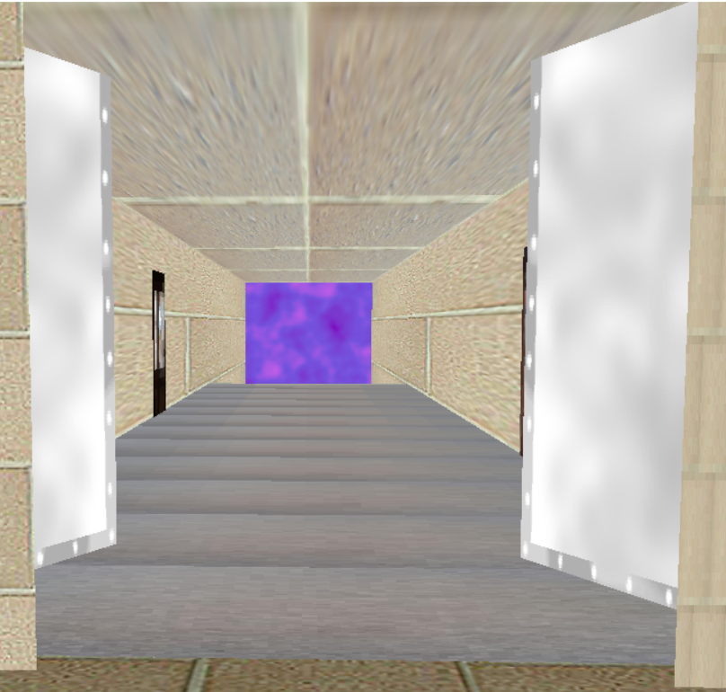

Figure 4: Shows portal beyond the iron doors

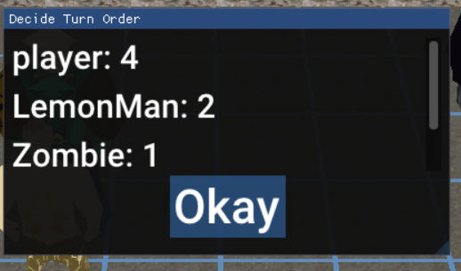Once you enter the portal you will see the game floor with figure 4 Below, you must wait for it to assign all players and characters a turn number then an “Okay” button will appear loading the main User Interface.

Figure 5: Turn order assignment box (okay button may take some time to appear due to turn assignment)

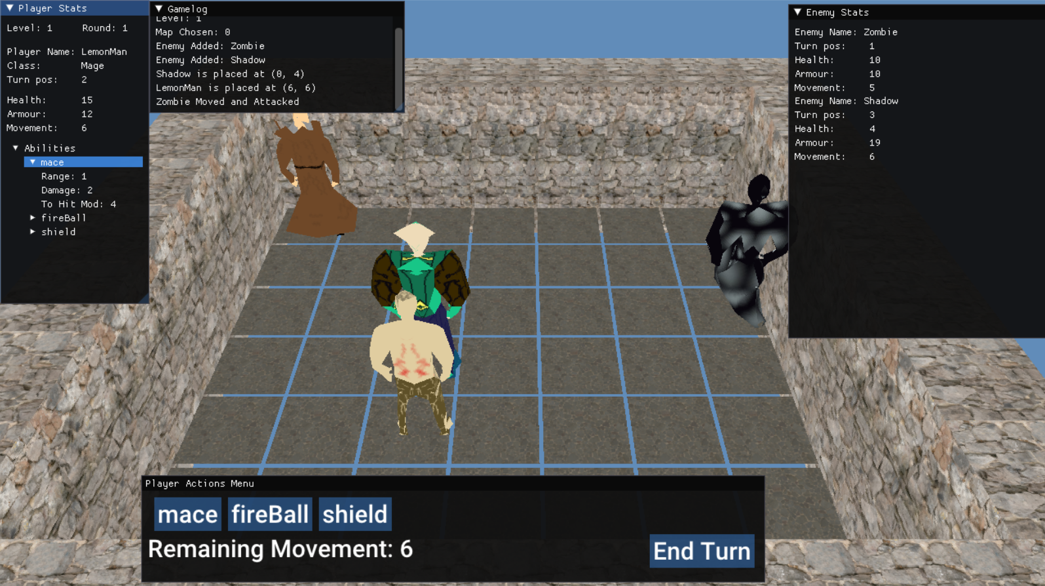Once the player has clicked “okay” figure 5, below, will be displayed showing you the current player stats, all enemy stats, game log, and the action menu (abilities, movement available, end turn).

Figure 6: main HUD for player turns

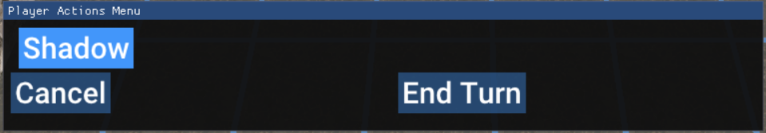When a player selects an ability if it not an Attack On Environment (AOE) then they will see figure 7 otherwise they will see an array underneath the player that can move via WASD, if permitted, see figure 8 and the action menu will change to figure 9.

Figure 7: Result of selecting non-AOE attack, gives list of enemies within range

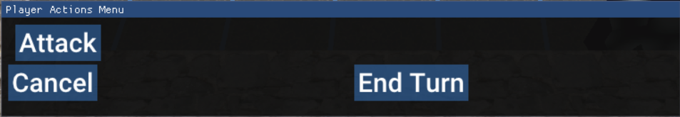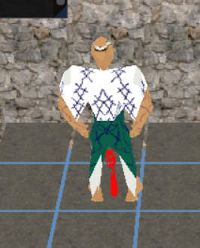

Figure 8: AOE indicator arrow below character model

Figure 9: Corresponding AOE attack menu

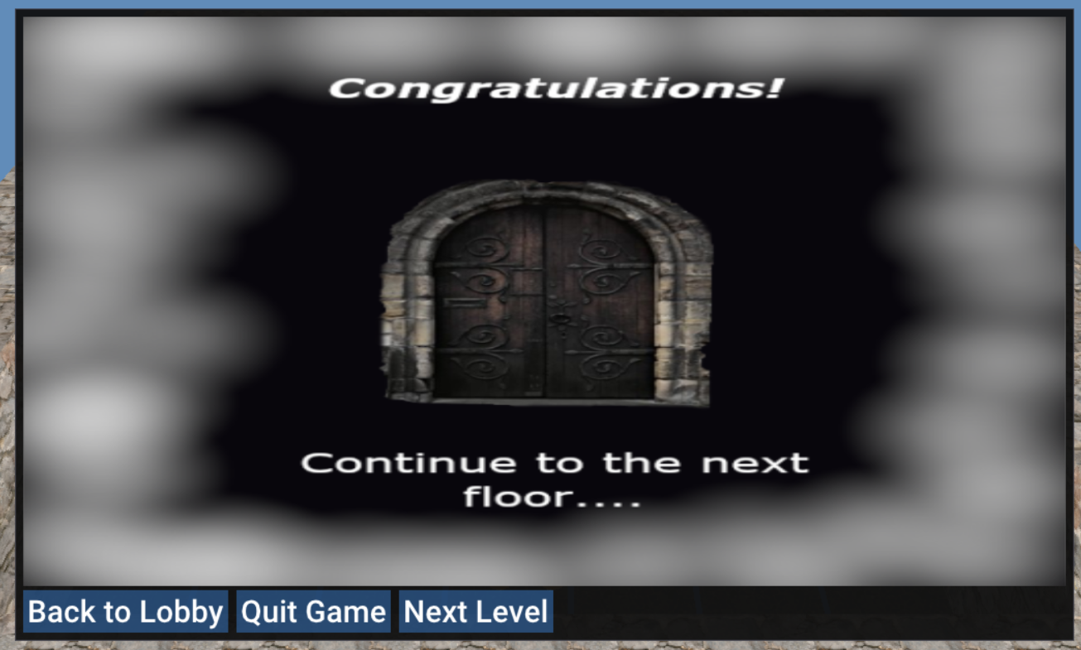Once all enemies are defeated and you end you turn you will get figure 6, congratulating you on clearing the level encouraging you to battle the next, with the options to return to the lobby (spawn) or quit the game.

Figure 10: Level cleared image

Upon clearing the game (10 levels) you will see figure 7, below, allowing you to replay by going back to lobby or quitting.

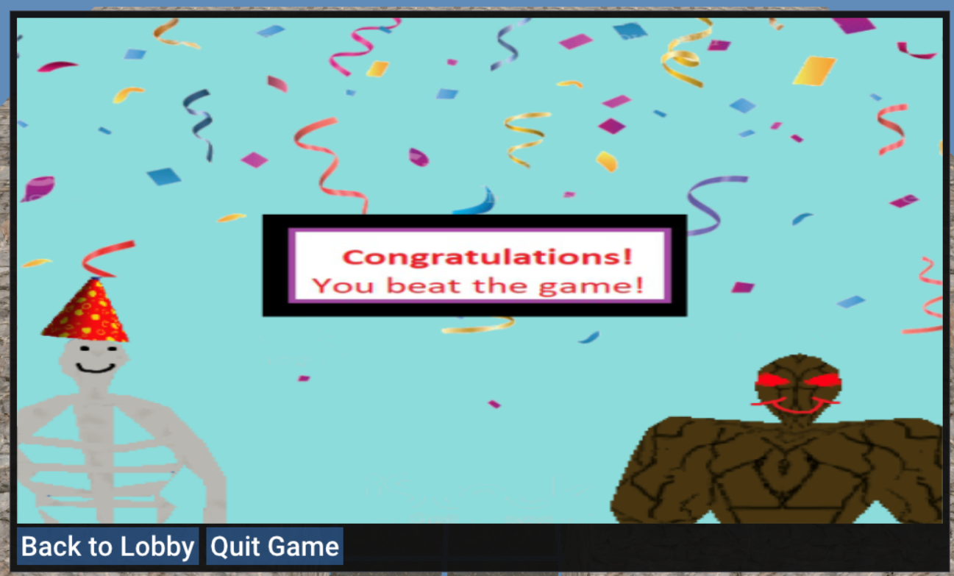

Figure 11: Game cleared screen

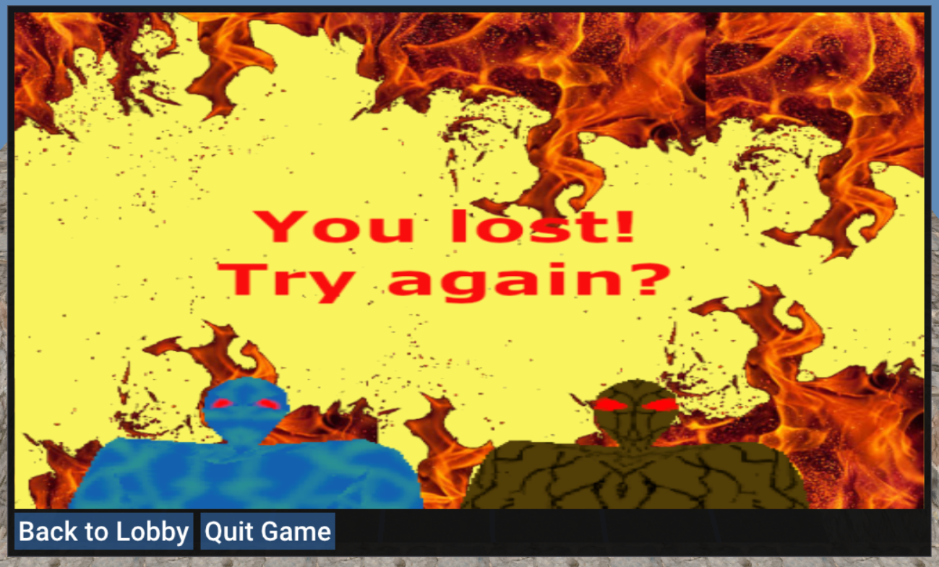If all players are defeated you get figure 8, notifying players of defeat encouraging them to play again through going back to the lobby or allowing them to quit.

Figure 12: Level lost screen

**Levels**

You can add your own levels to the game or modify existing levels via editing the maps.csv file under data/Levels directory. The structure is level number, size along X axis and size along Z axis. Then straight below is the corresponding map layout where 0 is an empty space and 1 is a pillar (obstacle).

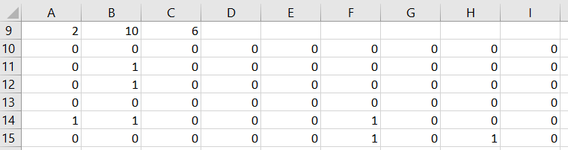

Figure 13: Sample layout of a pre-set for level 2

**Classes**

Players can add/modify classes to the game although new classes will only appear as a Monk and there are no preview images. The structure is class name, health, armour, movement, ability 1, ability 2, ability 3 (similar to enemy)

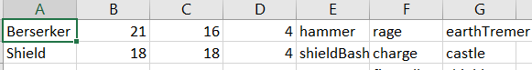

Figure 14: Sample of the class.csv file highlighting the structure

Players can add/modify classes to the game although new classes will only appear as a Monk and there are no preview images. The structure is ability name, range, AOE, repeat amount, damage, to hit modifier, stun chance, cooldown and unique Boolean.

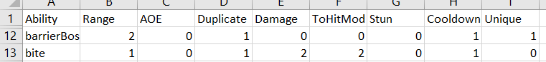

Figure 15: Sample of the abilities.csv file highlighting the structure

**Enemies**

Players can add/modify the enemy.csv file in data/Levels directory. The structure is Enemy name (case sensitive), health, armour, movement, ability 1, ability 2, ability 3

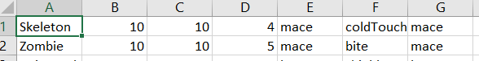

Figure 16: Sample of the enemies.csv file highlighting the structure

Players can add/modify the enemies that appear in each level by changing the enemiesPerLevel.csv in data/Levels directory. The structure is Level, min, max, and next line is a list of enemy names that are case sensitive.

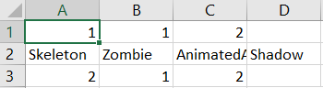

Figure 17: Sample of the enemiesPerLevel.csv file highlighting the structure